Functional Specification Document
  - OMEGA – Open Market Execution Gateway
  - Singapore Savings Bonds
  - v0.01

Document Control
Revision History
Revision # | Release Date | Summary of Changes | Author
0.01 | 09 Dec 2025 | Initial draft. | Eugene Cheong

Reviewer Name (Designation) | Reviewed Version # | Date

Approver Name (Designation) | Approved Version # | Date

Table of Contents
1 Introduction 5
1.1 Purpose of Document 5
1.2 Scope 5
1.3 Definitions, Acronyms and Abbreviations 5
1.4 Reference 6
2 Functional Requirements 6
2.1 Purpose of Module 6
2.2 Process Diagrams 6
3 Process Holdings Submission File 8
3.1 Description 8
3.2 Business Requirements and Assumptions 8
3.3 Processing Logic 8
4 SSB Housekeeping 10
4.1 Description 10
4.2 Business Requirements and Assumptions 10
4.3 Processing Logic 10
5 SSB Portal Sync 11
5.1 Description 11
5.2 Business Requirements and Assumptions 11
5.3 Processing Logic 11
6 Generate Coupon and Redemption Rates File 11
6.1 Description 11
6.2 Business Requirements and Assumptions 12
6.3 Processing Logic 12
7 Process Redemption Submission File 13
7.1 Description 13
7.2 Business Requirements and Assumptions 14
7.3 Processing Logic 14
8 Process Subscription Submission File 15
8.1 Description 15
8.2 Business Requirements and Assumptions 15
8.3 Processing Logic 16
9 Duplicate Verification Check 17
9.1 Description 17
9.2 Business Requirements and Assumptions 17
9.3 Processing Logic 17
10 Process Redemptions 17
10.1 Description 17
10.2 Business Requirements and Assumptions 18
10.3 Processing Logic 18
11 Allotment Via Quantity Ceiling Format 19
11.1 Description 19
11.2 Business Requirements and Assumptions 19
11.3 Processing Logic 19

Introduction

Purpose of Document
This Functional Specification Document is used to clearly define the intended functionality of OMEGA.
OMEGA is a platform that supports MAS’ central banking functions related to market operations and benchmark administration. OMEGA aims to improve business efficiency by leveraging on technology and design thinking, minimising manual intervention, re-engineering business processes and improving system resiliency.
OMEGA consists of several modules. This document outlines the functionality of the Bonds and Bills module, focusing on features, functions, and behaviour specifically for Singapore Savings Bonds, without detailing how these functionalities will be technically implemented. It aims to:
- Establish a shared understanding of the system's functional scope.
- Provide a clear and unambiguous description of each functional requirement.
- Ensure that the developed system meets the identified business needs and user expectations.
- Facilitate effective communication and collaboration among all project stakeholders.
- Serve as a baseline for system development, testing, and implementation.
- Manage and control changes to the system's functionality through a defined change management process.

Scope
The Bonds and Bills module allows the system to perform the following functionalities:
- Process holdings submissions files,
- Process subscription submissions files,
- Process redemption submissions files,
- Generate coupon and redemption rates files,
- Conduct allotment using the Quantity Ceiling Format,
- Process redemptions,
- Sync with the SSB Portal.

Definitions, Acronyms and Abbreviation
Acronym | Description
CDP | Central Depository Pte Limited
DBS | DBS Bank Limited – a Primary Dealer
MAS | Monetary Authority of Singapore
MEFT | MAS Enterprise File Transfer
MEPS+ | MAS Electronic Payment System+
NRIC | National Registration Identity Card
OCBC | Oversea-Chinese Banking Corporation – a Primary Dealer
OMEGA | Open Market Execution Gateway
PD | Primary Dealer
SRS | Supplementary Retirement Scheme
SSB | Singapore Savings Bonds
UOB | United Overseas Bank – a Primary Dealer
Table 1: Acronyms used in document

Reference
The following documents are referenced throughout this functional specification and should be consulted for additional context, detailed requirements, and technical information that supports the functional requirements described in this document.
- MAS_OMEGA – Functional Specifications Document (Issuance Calendar).docx
- MAS_OMEGA – Functional Specifications Document (Announcements).docx
- MAS_OMEGA – Functional Specifications Document (Allotment).docx
- MAS_OMEGA – Functional Specifications Document (Reports).docx
- MAS_OMEGA – Functional Specifications Document (Administration).docx
- MAS_OMEGA – Functional Specifications Document (Common Functions).docx
- MAS OMEGA - Interface Specifications Document - (FIs and CDP).docx
- MAS OMEGA - Interface Specifications Document - (MEPS+).docx
- MAS OMEGA - Interface Specifications Document - (SSB Portal).docx

Functional Requirements

Purpose of Module
OMEGA is able to handle processes that are specific to SSBs as listed in 1.2 Scope.

Process Diagrams
The figure below shows the high-level activities specific to SSBs in a calendar month:
 | 1st Working Day | 2nd Working Day | 3rd Working Day to 6th last working day | 5th Last Working Day | 4th Last Working Day | 3rd Last Working Day | 2nd Last and Last Working Day
7:00AM | Process Holdings Submission File
7:00AM |  | Coupon / Redemption Rate Generation
7:30AM | SSB Housekeeping
8:30AM |  | Process Redemption Submission File
9:00AM | Generate Issuance Report
9:00AM |  | Process Subscription File
9:30AM | SSB Portal Sync
9:30AM |  |  |  | Duplicate Verification |  | Duplicate Verification
10:00AM |  |  |  |  |  | Process Redemption
10:30AM |  |  |  |  |  | Process Allotment
10:45AM |  |  |  |  |  | Check Limit
3:00PM |  |  |  |  |  | Release Result
3:00PM |  |  |  |  |  | SSB Portal Sync
4:00PM |  |  |  |  |  | Generate Holdings Report
On or after 4:30PM | Publish  Announcement
Table 2 Overall Process for SSBs in a Calendar Month
In Oct/Nov of a given year, the issuance calendar of the following year for SSBs is published to the MAS website. For more information regarding the processes related to issuance calendars, refer to MAS_OMEGA – Functional Specifications Document (Issuance Calendar).
On the 1st working day of the month, the following processes are executed:
- Process Holdings Submission File (refer to 3 Process Holdings Submission File),
- SSB Housekeeping (refer to 4 SSB Housekeeping),
- Generation of Issuance Report,
- SSB Portal Sync (refer to 5 SSB Portal Sync),

- Announcement for the SSB to be issued is also updated, approved and published. For more information regarding the processes related to announcements, refer to MAS_OMEGA – Functional Specifications Document (Announcements).

On the 2nd working day of the month, the following processes are executed:
- Process Holdings Submission File,
- Coupon & Redemption Rates Submission (refer to 6 Generate Coupon and Redemption Rates File),
- Process Redemption Submission File (refer to 7 Process Redemption Submission File),
- Process Subscription Submission File (refer to 8 Process Subscription Submission File),
- SSB Portal Sync.
On the 3rd working day of the month to the 4th last working day of the month, the following processes are executed:
- Process Holdings Submission File,
- Process Redemption Submission File,
- Process Subscription Submission File,
- SSB Portal Sync.
On the 5th last working day of the month, an additional process is executed:
- Duplicate Verification (refer to 9 Duplicate Verification Check).
On the 3rd working day of the month, the following processes are executed:
- Process Holdings Submission File,
- Process Redemption Submission File,
- Process Subscription Submission File,
- SSB Portal Sync (once after the submission job and once after the allotment results are released),
- Duplicate Verification,
- Process Redemptions (refer to 10 Process Redemptions),
- Process Allotment (refer to 11 Allotment Via Quantity Ceiling Format),
- Check Limit (refer to …),

- Generate Holdings Report.
On the 2nd last and last working day of the month, the following processes are executed:
- Process Holdings Submission File,
- SSB Portal Sync.
This entire set of processes repeats on the next calendar month.
Note: For more information on the requirements for the Holdings Report and Issuance Report, refer to MAS_OMEGA – Functional Specifications Document (Reports). For more information regarding the interfacing between other systems for the processes in this document (such as the structure of the input and output files, the validations involved for each field of the files, and the method of encryption), refer to:
- MAS OMEGA - Interface Specifications Document - (FIs and CDP)
- MAS OMEGA - Interface Specifications Document - (MEPS+)
- MAS OMEGA - Interface Specifications Document - (SSB Portal)

Process Holdings Submission File

Description
Holdings Submission Files are provided by CDP for Cash holdings and provided by the Retail PDs (DBS, OCBC, and UOB) for SRS holdings. These files contain the holdings of each issuance of Singapore Savings Bonds by individuals.
For each file processed, an acknowledgement file is generated and deposited in MEFT. The acknowledgement files contains the status of the processed file and the status of the individual records.
CDP and the PDs can then retrieve the acknowledgement files from MEFT(?).

Business Requirements and Assumptions
- Submitted redemption requests are already deducted from the Holdings Submission File (i.e. the Holdings Submission File contains the individual holdings information after accounting for the redemption requests received up to that day).
- If there are no holdings records from CDP or the PDs, a file is still expected to be sent, but the holding information file only contains the Header and Control Record without the Detail Record sections.
- The Holdings Submission File deposited by CDP or the PDs into MEFT may be overwritten when an updated file is uploaded.
- The file name for the Holdings Submission File uploaded by CDP or the PDs must not contain any date or timestamp.

Processing Logic
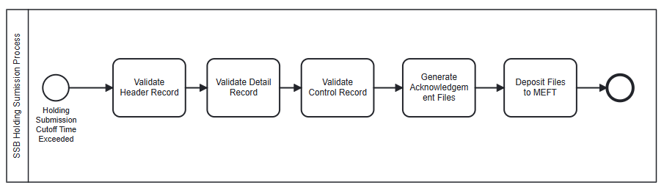
Figure 1 Overall Process Diagram
When the process is triggered for each file,
- Check if the current time is before the Holdings Submission Cutoff Time.
  - If yes, the process ends immediately.
- Attempt to retrieve the holding file.
- If the file is missing, the process ends immediately.
- Decrypt the file.
- If the decryption fails, go to step 8.
- Validate the contents of the file.
- Validate the header record.
    - If the header record is invalid, go to step 7.
- Process the detail records.
- Validate each detail record individually.
- If there is any error in the validation or if it is a duplicate record, reject the record.
- Else, continue validating the next detail record until there is no detail record left.
- Validate the control records.
- If the control record is invalid, go to step 7.
- Update the database.
- Previous holding information records are deleted.
- The validated holding information records are inserted into the database.
- Generate Holding Information Reports. The following reports are generated:
  - Detailed Holdings
  - Aggregated Report by Investor Profile
  - Current Info by Issue
For more information on requirements for these reports, refer to MAS_OMEGA – Functional Specifications Document (Reports).
- Generate the acknowledgement file and encrypt it.
- If the file decryption failed, the header record was invalid, or the control record was invalid, generate the acknowledgement file with a header record of file status “F” with a message to indicate the error. The control record will also have a record count of 0 and an overall checksum of 0.
- Else, generate the acknowledgement file with a header record of file status “P” as well as the detail records along with the status of each detail record processed. The control record will also include the record count and the overall checksum value.
- Send the encrypted acknowledgement file.
The process ends.

SSB Housekeeping

Description
Intermediate files, result files, reports and other files that are generated by OMEGA are housekept monthly. For more information on how the files are housekept, refer to MAS_OMEGA – Functional Specifications Document (Common Functions).
Data such as the holding information that are beyond a certain threshold are also housekept.

Business Requirements and Assumptions
- Files that are sent by third parties (e.g. PDs and CDP) to OMEGA do not require housekeeping because the files are overwritten on the next transfer.
- Files that are sent by OMEGA to third parties (e.g. PDs and CDP) also do not require housekeeping because the files are overwritten on the next transfer.
- Intermediate files created by other processes, such as the decrypted versions of the incoming files, and reports, are subject to housekeeping.

Processing Logic
When the process is triggered,
- Calculate the threshold date for housekeeping - the first day of the month, three months ago. For example, if the housekeeping process is triggered on 06 October 2025, the threshold date is 01 July 2025.
- Retrieve the holding information earlier than the threshold date.
  - If there is no data retrieved, no holding information is deleted from the SSB Portal.
  - Else, delete the data retrieved from OMEGA and from the SSB Portal.
- Retrieve the subscription submission records earlier than the threshold date.
  - If there is no data retrieved, no subscription submission record is deleted from the SSB Portal.
  - Else, delete the data retrieved from OMEGA and from the SSB Portal.
- Retrieve the redemption submission records earlier than the threshold date.
  - If there is no data retrieved, no redemption submission record is deleted from the SSB Portal.
  - Else, delete the data retrieved from OMEGA and from the SSB Portal.
The process ends.

SSB Portal Sync

Description
This process is to sync the data needed by the SSB Portal from OMEGA as the source.

Business Requirements and Assumptions
- Only the data that was inserted or modified since the last successful run is synced to the SSB Portal.

Processing Logic
When the process is triggered,
- Retrieve the applicant data which was updated or added since the last successful run.
  - If there is no change or new data added, no applicant data is synchronised to the SSB Portal.
  - Else, synchronise the data to the SSB Portal.
- Retrieve the holding information data which was updated or added since the last successful run. This includes holding information from all types of holdings such as Cash and SRS.
  - If there is no change or new data added, no holding information is synchronised to the SSB Portal.
  - Else, synchronise the data to the SSB Portal.
- Retrieve the latest allotment results and subscription records since the last successful run.
  - If there is no change or new data added, no allotment result or subscription record is synchronised to the SSB Portal.
  - Else, synchronise the data to the SSB Portal.
- Retrieve the redemption records and redemption results since the last successful run.
  - If there is no change or new data added, no redemption record or redemption result is synchronised to the SSB Portal.
  - Else, synchronise the data to the SSB Portal.
- Retrieve the coupon and redemption rates since the last successful run.
  - If there is no change or new data added, no coupon and redemption rate is synchronised to the SSB Portal.
  - Else, synchronise the data to the SSB Portal.
- Retrieve the details of the security since the last successful run.
  - If there is no change or new data added, no security detail is synchronised to the SSB Portal.
  - Else, synchronise the data to the SSB Portal.
The process ends.

Generate Coupon and Redemption Rates File

Description
The Coupon and Redemption Rates File is a file provided to CDP and the Retail PDs (DBS, OCBC, and UOB) through MEFT(?). These files contain the coupon date, coupon rates, and the redemption rate for SSB active issuance.
CDP and the Retail PDs can retrieve the Coupon and Redemption Rates files in MEFTT.

Business Requirements and Assumptions
- This process can also be manually triggered. For more information on how to trigger the process manually, refer to MAS_OMEGA – Functional Specifications Document (Administration).

Processing Logic
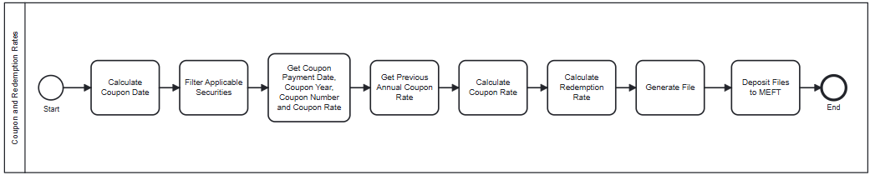
Figure 1 Overall Process Diagram
When the process is triggered on the Processing Date,
- Prepare the data required to calculate the coupon rates and redemption rates.

  - Based on the Processing Date, calculate the Coupon Date and the Early Redemption Date. The Coupon Date is the 1st day of the following month of the Processing Date, and the Early Redemption Date is the 1st working day of the following month of the Processing Date.
  - For each SSB with the maturity date >= Coupon Date and is not open for subscription, retrieve the Previous Annual Coupon Rate, Current Annual Coupon Rate, and the Next Annual Coupon Rate.
    - This information is obtained from MEPS+ when processing the couponrates_sbond.txt.
    - When sorted by ascending order of coupon year and number, retrieve the first two records where MEPS+ Coupon Payment Date >= Coupon Date. The 1st record is the Current Annual Coupon Rate while the 2nd record is the Next Annual Coupon Rate.
    - When sorted by descending order of coupon year and number, retrieve the first record where MEPS+ Coupon Payment Date < Coupon Date. This record is the Previous Annual Coupon Rate.
- Calculate the coupon rates.
  - If the issue date falls on the 1st calendar day of the month, calculate the regular coupon rate payment using the formula:
$$CPN_RATE = (\frac{CPN}{2})$$
where CPN is the Current Annual Coupon Rate.

  - Else, if the Current Annual Coupon Rate is based on Coupon Year = 1 and Coupon Number = 1, calculate the first irregular coupon payment using the formula:
$$CPN_RATE= \left(\frac{CPN}{2}\right) ×(\frac{DC}{PC})$$

where CPN = Current Annual Coupon Rate,
DC = No. of days between Issue Date and First Coupon Payment Date,
PC = No. of days between the first calendar day of the issuance month and the first calendar day of the coupon payment month.

- Calculate the redemption rates.
  - If the Coupon Date != Current Coupon Payment Date and the Current Coupon Year = 1 and the Current Coupon Number = 1 (i.e. the security has not reached its first coupon payment date),
$$RDM_RATE= \left(\frac{CPN}{2}\right) ×\left(\frac{DC}{PC}\right)$$
where CPN = Current Annual Coupon Rate,
DC = No. of days between Issue Date and Early Redemption Date,
PC = No. of days between the first calendar day of the issuance month, and the first calendar day of the coupon payment month.

  - Else, if the Early Redemption Date < Current Coupon Payment Date,
$$RDM_RATE= \left(\frac{CPN}{2}\right) ×\left(\frac{DC}{PC}\right)$$
where CPN = Current Annual Coupon Rate,
DC = No. of days between previous coupon payment date and Early Redemption Date,
PC = No. of days between the previous coupon payment date and next coupon payment date.

  - Else, if there is no Next Coupon Payment Date, or if the Early Redemption Date = Current Coupon Payment Date,
$$RDM_RATE= 0$$

  - Else, the final scenario is where Early Redemption Date > Current Coupon Payment Date,
$$RDM_RATE= \left(\frac{CPN}{2}\right) ×\left(\frac{DC}{PC}\right)$$
where CPN = Next Annual Coupon Rate,
DC = No. of days between early redemption date and current coupon payment date,
PC = No. of days between the current coupon payment date and next coupon payment date.

- Generate the file and encrypt it for each Retail PD and CDP.
- Send the encrypted Coupon and Redemption Rates File.
The process ends.

Process Redemption Submission File

Description
The Redemption Submissions File is a file provided by CDP for Cash, as well as by each Retail PDs (DBS, OCBC, and UOB) for SRS. This file contains the redemption submission requests for every SSB issuance.
An acknowledgement file is sent to CDP for Cash redemptions, and to each Retail PDs for SRS redemptions. The acknowledgement files contain the status of the processed file and the status of the individual redemption records.
CDP and the PDs can retrieve the acknowledgement files in MEFT(?).

Business Requirements and Assumptions
- Each redemption file can contain multiple security codes of Savings Bonds that have not been matured yet.
- In the event there is no redemption record, the file is still expected to be sent, but only contains the Header and Control record.
- Retail PDs/CDP must ensure the redemption records sent are before the blackout period.
- The redemption file deposited by Retail PDs/CDP is overwritten when an updated file is uploaded.
- The name for the redemption file uploaded by CDP or the Retail PDs should not contain any date or timestamp.

Processing Logic
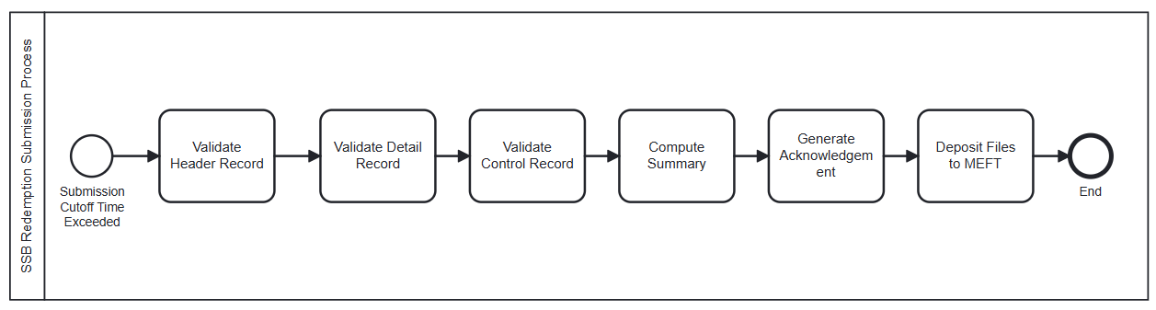
Figure 1 Overall Process Diagram
When the process is triggered for each file,
- Check if the current time is before the Redemption Submission Cutoff Time.
  - If yes, the process ends immediately.
- Attempt to retrieve the redemption submission file.
- If the file is missing, the process ends immediately.
- Decrypt the file.
- If the decryption fails, go to step 7.
- Validate the contents of the file.
- Validate the header record.
    - If the header record is invalid, go to step 7.
- Process the detail records.
- For each detail record, validate the detail record.
- If there is any error in the validation or if there is a duplicate record, reject the record.
- Else, continue validating the next detail record.
- Validate the control records.
- If the control record is invalid, go to step 7.
- Update the database based on processed detail records (include records which passed and failed validations).
- Update the database with the summary for each Retail PDs and CDP:
  - Processing Date/Time,
  - Issue Code,
  - Bank Code,
  - Application Type,
  - Total records submitted,
  - Total redeemed amount submitted,
  - Total records rejected,
  - Total records successful,
  - Total redeemed amount successful.
- Generate the acknowledgement file and encrypt it.
- If the file decryption failed, the header record was invalid, or the control record was invalid, generate the acknowledgement file with a header record of file status “F” with a message to indicate the error. The control record also has a record count of 0 and an overall checksum of 0.
- Else, generate the acknowledgement file with a header record of file status “P” as well as the detail records along with the status of each detail record processed. The control record also includes the record count and the overall checksum value.
- Send the encrypted acknowledgement file.
The process ends.

Process Subscription Submission File

Description
The Subscription Submissions File is a file provided by each Retail PDs (DBS, OCBC, and UOB), with 1 file for Cash, and 1 fil for SRS. This file contains the subscription request for the SSB issuance that is open.
For each subscription file processed, an acknowledgement file is generated and deposited in MEFT(?). The acknowledgement files contain the status of the processed file as well as the status of the individual records.
The PDs can retrieve the acknowledgement files from MEFT(?).

Business Requirements and Assumptions
- Each subscription file contains subscription requests for the only issuance that is open.
- If there is no subscription record, a file is still expected to be sent, but only contains the Header and Control Record.
- The subscription file deposited by PDs is overwritten when an updated file is uploaded.
- The name for the subscription file uploaded by the PDs should not contain any date or timestamp.

Processing Logic
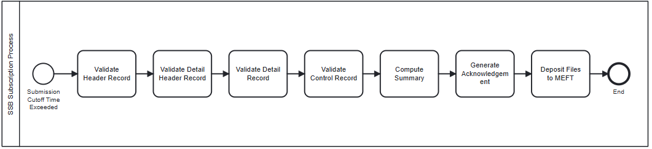
Figure 1 Overall Process Diagram
When the process is triggered for each file,
- Check if the current time is before the Subscription Submission Cutoff Time.
  - If yes, the process ends immediately.
- Attempt to retrieve the Subscription Submission file.
- If the file is missing, the process ends immediately.
- Decrypt the file.
- If the file decryption fails, go to step 7.
- Validate the contents of the file.
- Validate the header record.
    - If the header record is invalid, go to step 7.
- Process the detail records.
    - For each detail record, validate the detail record.
    - If there is any error in the validation or if it is a duplicate record, reject the record.
    - Else, continue validating the next detail record.
- Validate the control records. If the control record is invalid, go to step 7.
- Update the database based on processed detail records (include records which passed and failed validations).
- Update the database with the summary for each PD:
  - Processing Date/Time,
  - Issue Code,
  - Bank Code,
  - Application Type,
  - Total records submitted,
  - Total amount submitted,
  - Total records rejected,
  - Total records successful,
  - Total amount submitted successfully.
- Generate the acknowledgement file and encrypt it.
- If the file decryption failed, the header record was invalid, or the control record was invalid, generate the acknowledgement file with a header record of file status “F” with a message to indicate the error. The control record will also have a record count of 0 and an overall checksum of 0.
- Else, generate the acknowledgement file with a header record of file status “P” as well as the detail records along with the status of each detail record processed. The control record will also include the record count and the overall checksum value.
- Send the encrypted acknowledgement file.
The process ends.

Duplicate Verification Check

Description
A duplicate verification check is done for the processed subscription request for the new issuance and latest holding records for individuals who have different CDP account numbers or if a CDP account number is used by multiple individuals, where individuals are identified by their NRIC or passport number.

Business Requirements and Assumptions
- The duplicate verification check validates whether an individual with the same NRIC or passport number has different CDP account numbers, and vice versa.

Processing Logic
When the process is triggered,
- Retrieve the processed subscription requests submitted within the same month that were not rejected.
- For each NRIC or passport number, check the CDP account number associated with the subscription request.
  - If the subscription requests for the individual have more than one CDP account number associated with it, reject all bids submitted under the NRIC or passport number.
- For each CDP account number, check the NRIC or passport number associated with the subscription request.
  - If the subscription requests for the CDP account number have more than one NRIC or passport number associated with it, reject all bids submitted under the CDP account number.
- Send email notification to the users if there is any duplicate found
- The process ends.

Process Redemptions

Description
The redemption process is triggered to process the redemption submissions that were previously collated.

Business Requirements and Assumptions
- The Retail PDs and CDP check that the redemption submission requests are valid before sending the redemption submission requests to OMEGA. As such, the redemption result for each submission is expected to be fully redeemed.

Processing Logic
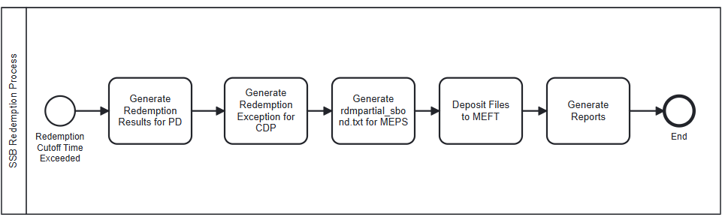
Figure 1 Overall Process Diagram
When the process is triggered,
- Check if the current time is before the Redemption Cutoff Time. If yes, the process ends.
- Using the valid redemption submissions from the 2nd working day of the month to the current day, generate the results file and encrypt it.
  - The results file is separate for Cash transactions and SRS transactions for each Retail PDs and CDP. The Retail PD result file for Cash and SRS includes the redemption results for requests submitted by the respective Retail PD only. The CDP result file for Cash transactions and SRS transactions includes the redemption results for requests submitted by all Retail PDs.
  - The MEPS+ consolidated redemption result file is also generated which includes both Cash transactions and SRS transactions for each Retail PD.
- Generate the following reports:
  - Detailed Redemption Report
  - Aggregate Redemption by PDs Report
  - Aggregate Redemption by Investors Profile (Nationality/Residency) Report
  - Aggregate Redemption by Redeemed Amount Report
  - Redemption by Issue Code Report
For more information on requirements for these reports, refer to MAS_OMEGA – Functional Specifications Document (Reports).
- Send the encrypted redemption results file.
The process ends.

Allotment Via Quantity Ceiling Format

Description
This process allots SSBs based on the subscription requests received by the closing date. It also validates the individual holdings and subscription amounts against the individual per issue limit and individual aggregate limit.
When the allotment results are released, result files are generated for the Retail PDs, CDP, as well as MEPS+.

Business Requirements and Assumptions
- The random seed value generated does not change if the allotment is triggered to re-run.
- The following are configurable in the security type parameter settings:
  - Max Allotment Per Issuance
  - Minimum Denomination
  - Max Allotment Aggregate Limit
For more information on the configurations, refer to MAS_OMEGA – Functional Specifications Document (Administration).docx

Processing Logic
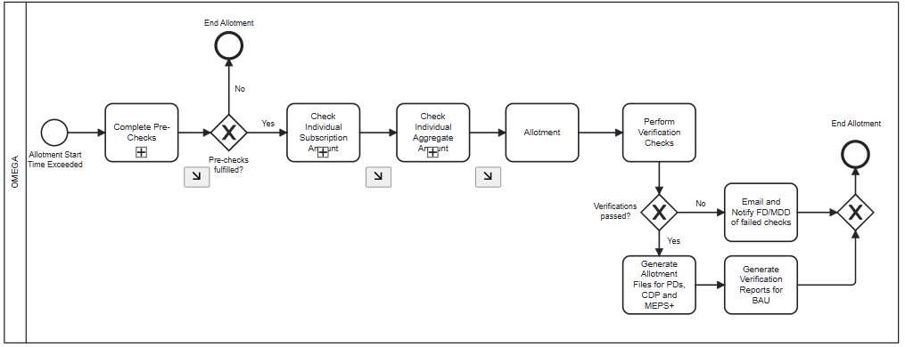
Figure 1 Overall Process Diagram
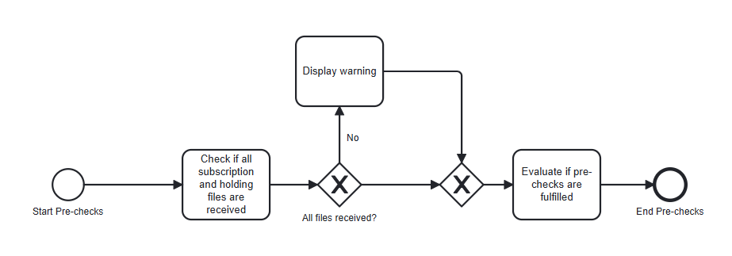
Figure 2 Process Diagram for Pre-checks
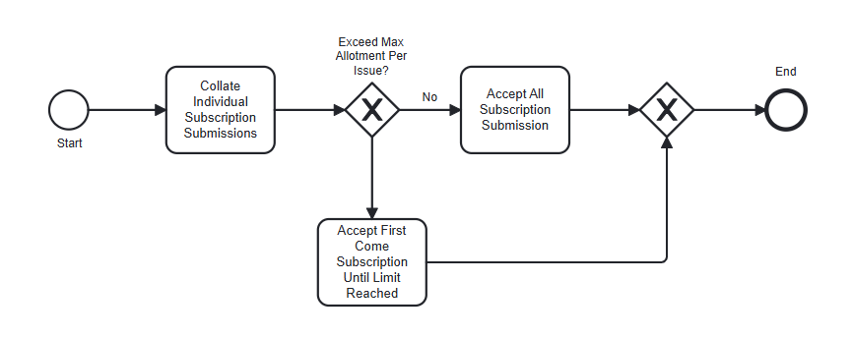
Figure 3 Process Diagram for Checking Individual Subscription Amounts
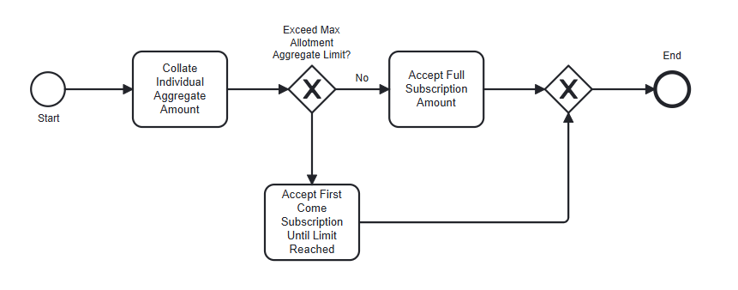
Figure 4 Process Diagram for Checking Individual Aggregate Amounts
When the process is triggered,
- Check if the current time is before the Allotment Cutoff Time. If yes, the process ends immediately.
- Check if any holdings and subscription files have been received by CDP and the Retail PDs for the current calendar month. If there is no holdings file or if there is no subscription file received, the process ends and a warning is shown for the allotment.
- Obtain the issue code for the SSB for which the allotment date lies on the current system date.
  - If there is no allotment on the current system date, the process ends immediately.
- Retrieve the subscription records for the issue code.
  - If there is no subscription record found, the process ends immediately.
- Check the individual subscription amount.
  - Sort the subscription records (both Cash and SRS) in ascending order of NRIC or passport number and follow by submitted date/time.
  - Retrieve the value of the Max Allotment Per Issuance.
  - For each individual,
    - If the Applied Amount > Issue Limit, then accept the subscriptions on a first-come first-accept basis until the Accepted Amount = Issue Limit.
    - Else, accept all subscriptions such that the Accepted Amount = Applied Amount.
- Check the individual aggregate amount.
  - Sort the subscription records (both Cash and SRS) in ascending order of NRIC or passport number and follow by submitted date/time.
  - Retrieve the Max Allotment Aggregate Limit, which is the limit across all issuances.
  - For each individual,
    - Retrieve their Holdings Amount (both Cash and SRS).
    - If the Holdings Amount + Accepted Amount > Max Allotment Aggregate Limit, then accept the subscriptions on a first-come first-accept basis until the Holdings Amount + Accepted Amount = Max Allotment Aggregate Limit.
    - Else, do not change the Accepted Amount.
- Compute the total accepted subscription amount.
  - If total accepted subscription amount <= Issue size, all individuals will be fully allotted based on the Accepted amount subscribed.
  - If total accepted subscription amount > Issue size, OMEGA will need to perform the tiered allotment (Quality Ceiling Format) for the individuals.

Under this allotment mechanism,
- OMEGA will first generate a random seed value.
- Each individual will be allotted the minimum denomination. The amount allotted will increase in multiples of this minimum denomination for every applicant until the applicant has received the full amount accepted for, or until the amount of bonds has been reached whichever comes first.
- If the number of applicants is so large that issuing the minimum denomination will exceed the amount of bonds available, the bonds will be allocated amongst the remaining applicants randomly based on the random seed value generated.
- Post validation checks:
  - Validate if the total amount allotted <= issue size. If yes, update the subscription records with the allotted amount.
  - If the total amount allotted > issue size, notify users.

- Generate Verification Reports. The following reports are generated:
  - High Level Subscription Submission Report
  - Allotment Detailed Report
  - Allotment Aggregate Report by PDs
  - Allotment Aggregated Report by Investor Profile (Nationality/Residency)
  - Allotment Aggregated Report by Applied Amount
For more information on requirements for these reports, refer to MAS_OMEGA – Functional Specifications Document (Reports).
The results verification and release will occur at this stage and follows the steps described in MAS_OMEGA – Functional Specifications Document (Allotment). However, for SSBs, the results will be released after successful verification as described in step 10 below.
- Generate the results file and encrypt it.
  - The results file will be separate for Cash transactions and SRS transactions for Retail PDs and CDP. The Retail PD result file for Cash and SRS will include the allotment results for the requests submitted by the respective PDs only. The CDP result file for Cash transactions and SRS transactions will include the allotment results for requests submitted by all Retail PDs.
  - There will also be a MEPS+ consolidated allotment result file generated which include both Cash transactions and SRS transactions for each Retail PD.
- Send the encrypted allotment results file.
The process ends.

